1.3 – Algebraic Expression

Exponential Function / Power: b^{x}
(Such as 2⁵, which represents 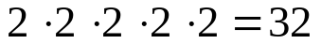)

Base: the number being multiplied; b

Exponent:

Variable: a letter that is used to represent one or more numbers (x)

Coefficient:

Evaluating Powers

Power ↔ Terms

Ex: 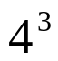

Quick Quiz:
Evaluate 5⁴

Write 3*3*3*3*3*3*3*3 as a power

Order of Operations; PEMDAS (work left to right)
P = (Please)
E = (Excuse)
M = (My)
D = (Dear)
A = (Aunt)
S = (Sally)

Ex: 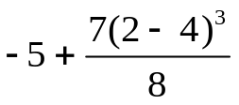=

Quick Quiz: 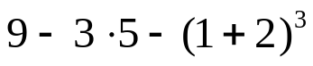

Evaluating Expressions
Evaluating the expression = replacing the variables with numbers

Write Algebraic Expression → Replace Variables → Simplify

Ex: Evaluate 3(x +2) – 6x – 8 when x = 4

Quick Quiz: You have $40 and want to buy songs from itunes. Each song costs $1.75 to download. Write an expression for the how much money you would have left after buying and downloading your itunes, n. Evaluate the expression when n = 20 and n = 15.

Simplifying Expressions
Combining like terms
- Like Terms: terms that have the same variable
(4x and 8x both have variable x)

Ex: Simplify 12(n² + n) – 3(n² – 2n)

Quick Quiz: Simplify 7x(x – 3) – 3(x + 4)+x^2

HMWK:
Honors/Regular pg 22-23 #13-23 (odd), 33-37, 41-42, 52

